**Title:** Nuisance species compromise carbon sequestration potential in an Eastern US temperate deciduous forest

**Authors :**

Luca L. Morreale1,2*

Rachel Hoffman1

Krystal Bagnaschi1

Iris Kennedy1

Erin MacMonigle1

Caroline Troy1

Cameron Dow1,3

Valentine Herrmann1 ( Orcid ID : 0000-0002-4519-481X)

Jennifer Jordan1,4 ( Orcid ID : 0000-0001-5521-360X)

Lukas Magee1,5

David Mitre2

Christopher Pate1

Jessica Shue6

Norman A. Bourg1

William J. McShea1

Kristina J. Anderson-Teixeira1,2 ( Orcid ID : 0000-0001-8461-9713)

**Author Affiliations:**

1. Conservation Ecology Center, Smithsonian’s National Zoo & Conservation Biology Institute, Front Royal, Virginia 22630, USA
2. Forest Global Earth Observatory, Smithsonian Tropical Research Institute, Apartado Postal 0843-03092, Panama City, Panama
3. Department of Biology, West Virginia University, Morgantown, West Virginia 26506, USA
4. Department of Environmental Science and Public Policy, George Mason University, Fairfax, Virginia 22030, USA
5. School of Forest, Fisheries and Geomatics Sciences, University of Florida, Gainesville, Florida 32603, USA
6. Forest Global Earth Observatory, Smithsonian Environmental Research Center, Edgewater, Maryland 21037, USA

*corresponding author: [MorrealeLL@si.edu](mailto:MorrealeLL@si.edu);

**Running head:**

for submission to Anthromes joint special collection in New Phytologist/ Plants, People, Planet: <https://www.newphytologist.org/news/view/332>

## ── Attaching core tidyverse packages ──────────────────────── tidyverse 2.0.0 ──  
## ✔ dplyr 1.1.3 ✔ readr 2.1.3  
## ✔ forcats 1.0.0 ✔ stringr 1.5.0  
## ✔ ggplot2 3.4.4 ✔ tibble 3.2.1  
## ✔ lubridate 1.9.0 ✔ tidyr 1.3.0  
## ✔ purrr 1.0.1   
## ── Conflicts ────────────────────────────────────────── tidyverse_conflicts() ──  
## ✖ dplyr::filter() masks stats::filter()  
## ✖ dplyr::lag() masks stats::lag()  
## ℹ Use the conflicted package (<http://conflicted.r-lib.org/>) to force all conflicts to become errors

*(Word limit: 6,500 words)*

# Summary

*Summary format for New Phytologist must be under 200 words and should be organized using four bullet points to indicate: (1) the research conducted, including the rationale, (2) methods, (3) key results, and (4) the main conclusion, including the key points of discussion*

Temperate deciduous forests play a critical role in the global carbon (C) cycle, accounting for a substantial portion of the global forest C sink. The dominant view imbued in Earth System Models is that, at least within the eastern United States, the biome is likely to remain a C sink throughout the 21st century. However, these models do not incorporate nuisance species – *i.e.*, species whose local abundance has increased as a result of human activities and that are causing ecological harm. Nuisance species are known to increase tree mortality (*e.g.*, non-endemic pests and pathogens) and decrease recruitment (*e.g.*, deer and non-endemic plants) throughout the temperate deciduous biome, yet the net effect on current and future C cycling is unknown. Here, we use 15 years of detailed census data from a large (25.6 ha) forest dynamics plot in a Mid-Atlantic temperate forest, including a 4-ha deer exclosure, to understand how nuisance species are affecting C cycling. We show increased biomass mortality, a net reduction in aboveground C storage, and decreased abundance of canopy tree species in the understory. Under current trends this forest will continue to lose C sequestration capacity, indicating that the C sequestration of temperate deciduous forests is likely overestimated.

**Keywords**:

*New Phytologist allows 5-8 keywords. Short phrases are acceptable*

# 1 Introduction

The temperate forest biome plays a critical role in the global carbon cycle, accounting for almost half of the net global forest carbon (C) sink (Harris *et al.*, 2021), with temperate deciduous forests alone sequestering >300 Tg C yr-1 (Pugh *et al.*, 2019). Although currently a net C sink, the future of the temperate forest biome remains uncertain. The dominant pattern projected by Earth System Models is a continued, albeit weakening, temperate forest C sink for the remainder of the 21st century (Ahlström *et al.*, 2012; Wu *et al.*, 2023). Yet, global C models predict a wide range of future trajectories of CO2 sequestration (Ahlström *et al.*, 2012; Arora *et al.*, 2020), and current global C models do not represent some influential mechanisms (e.g., Fatichi *et al.*, 2014; Clark *et al.*, 2021). One mechanism that is not represented in global C models is the impact of nuisance species – i.e., indigenous or non-indigenous species that, as a result of human influence, have much greater abundance in an ecosystem than they did historically, resulting in undesirable ecological consequences (**refs?**). Similarly, the impact of nuisance species on forest carbon budgets is not considered in machine learning or niche models that seek to project future forest distribution and carbon stocks, nor in carbon offset projects (Wu *et al.*, 2023). This is problematic in that nuisance species – including non-indigenous insect pests and pathogens, non-indigenous plants, and over-abundant herbivores – are dramatically impacting carbon cycling in temperate deciduous forests around the world.

Non-indigenous pests and pathogens can have a protracted impact on forests, often modifying forest productivity, nutrient cycling, successional trajectories, and geomorphic processes (Lovett et al. 2016, Fischer et al. 2013, Herms and McCullough 2014, Fei et al. 2014). Historically introduced to new ecosystems through intercontinental trade, non-indigenous forest insects and diseases will continue to proliferate with increased globalization and human movement (Fischer et al. 2013, Aukema et al. 2010, Brockerhoff et al. 2006). Many of the prominent pests and pathogens in temperate deciduous forests have dramatic effects on canopy composition and structure, decimating once-abundant canopy species (Aukema et. al 2010,Anderson-Teixeria 2021, Klooster et al. 2013, Ellison et al. 2018). Since many pests and pathogens do not currently occupy the full extent of their host species range, a significant portion of the remaining forest canopy is susceptible to future invasion from nuisance species, further increasing potentials for biomass loss and altered carbon cycle dynamics (Fei et al. 2013).

White-tailed deer (*Odocoileus virginianus*) are a nuisance species prevalent in eastern deciduous forests.*Start with a stronger sentence about the impact of deer on herbivory - Ex. White-tailed deer are the dominant herbivore in eastern deciduous forests (Reference)* Their populations have dramatically increased in the past 50 years (McShea et al. 1997). *Find a reference with a specific number of increase in deer populations* due in large part to global change drivers. (Found in McGarvey et al. 2013 – Brown et al. 2000, Côté et al. 2004, Rooney 2001). White-tailed deer preferentially browse on woody plant species in their earliest life stages (McGarvey et al. 2013), with overabundant herbivory reduce seedling and sapling survival, growth and density (Found in McGarvey et al. 2013 – Dzieciolowski 1980, Gill and Beardall 2001, Healy 1997, Konig 1976, Putman et al. 1989). Chronic overabundance has been shown to reduce understory diversity and decrease the abundance of traditionally dominant species (*NEW CITATION*). Due to climate change and human activity, many non-endemic plant species are being introduced or number in forest ecosystems (Reference). Deer find many of these species, including pawpaw (Asimina triloba), to be unpalatable (Found in McGarvey 2013 – Asnani 2006), and do not consume them at the same rates relative to their native counterparts (Reference), enabling them to form dense stands in forest understories (Found in Knauer et al. 2023 – Horsley and Marquis 1983; Stromayer and Warren 1997; Royo and Carson 2006). This lack of browsing pressure, coupled with characteristics such as fast growth rate and greater adaptability to altered conditions precipitated by climate change, allow nuisance plant species to outcompete other species in the understory (Reference). The interaction of these nuisance species on the landscape contributes to a recruitment failure in forests, [*Where individuals from certain tree species do not enter the mature population - Do we need to define recruitment failure, or is that considered common knowledge? If so, reference*). The extent of the consequences derived from recruitment failure on species composition and forest structure is often not apparent for years (McGarvey et al. 2013)

The capacity to regenerate following disturbances, including ongoing gap formation through mortality of canopy trees, critically influences long-term forest dynamics. Regeneration depends first upon seed production and then upon seedling recruitment, survival, and growth into trees. When any one of these steps fails, the stage is set for disturbance to push forest ecosystems over a tipping point, whereby there is little chance that a forest will recover to it’s pre-disturbance state in the foreseeable future (**refs?**). Global change pressures can set the stage for such critical transitions by gradually shifting baseline conditions, making post-disturbance recovery unlikely despite the persistence of mature trees (Anderson-Teixeira *et al.*, 2013; McDowell *et al.*, 2020; **refs?**). In the mid-Atlantic region of eastern North America, forests face a severe “regeneration debt”, meaning that there are insufficient juveniles of current canopy tree species to replace the mature cohort when they eventually die (Miller & McGill, 2019; Miller *et al.*, 2023). Low juvenile abundance in the region is driven by a combination of over-abundant deer, competition with non-endemic species, and possibly climate change (Russell *et al.*, 2017; Miller & McGill, 2019; Gorchov *et al.*, 2021; Miller *et al.*, 2023). Deer are the biggest problem (Gorchov *et al.*, 2021). The juveniles that are present tend to represent a different, more mesophytic set of species (*Acer spp.*, *Fagus grandifolia*) than currently dominate much of the region (*Quercus spp.*, *Carya spp.*, Miller & McGill (2019); Nowacki & Abrams (2015)]–a dynamic driven by fire suppression and mesophication (**refs?**).

Understanding the combined effects of multiple nuisance species on forest ecosystem processes requires data on both the forest understory and canopy over extended time periods. Here, we use 15 years of detailed census data from a large forest dynamics plot including a 4-ha deer exclosure to test the following hypotheses: (1) Aboveground C stocks in living biomass have declined since the initial census (-∆AGB) (2) canopy tree mortality and associated woody biomass loss are increasing, in large part due to non-indigenous nuisance species (3) Recruitment and biomass gains from tree growth have not kept pace with tree mortality, suggesting that future mortality will result in substantial net biomass loss and sustained decrease in the C storage potential of this ecosystem.

# 2 Materials and Methods

## 2.1 Site Description

The study was conducted in the 25.6-hectare Large Forest Dynamics plot at the National Zoo and Conservation Biology Institute in Front Royal, Virginia (38 $​^{∘}$ 53’ 36.6’‘N, 78 $​^{∘}$ 08’ 43.4’’W). The plot, which is located in the central Appalachian Mountains adjacent to Shenandoah National Park, is composed of mature secondary eastern deciduous forest. Situated in the Appalachian Oak forest region, the canopy is dominated by tulip poplar (*Liriodendron tulipifera*), oak (*Quercus* spp.), and hickory (*Carya* spp.) and the understory is primarily composed of spicebush (*Lindera benzoin*), paw-paw (*Asimina triloba*), American hornbeam (*Carpinus caroliniana*), and witch hazel (*Hamamelis virginiana*). The land-use history of the site is varied, including periods of agricultural development and intensive logging, with dendrological data estimating canopy tree establishment around 1900 (SI archives, Bourg et al. 2013). Natural disturbances at the plot consist of wind and infrequent ice storms (Anderson-Teixiera 2015). The plot, which includes a four-hectare deer exclosure that has decreased the presence of deer since 1990, is divided into 640 quadrats, each measuring 20 x 20 meters. It is one of 78 sites in the Forest Global Earth Observatory (ForestGEO), a global network of forest dynamic plots that promotes comparative forest ecology studies around the world.

In addition to our consideration of the plot as a whole, we give special consideration to three portions of the plot, all upland forest (i.e., excluding low-lying areas around streams): (1) Low deer, low canopy vulnerability: A 4-ha portion of upland forest in the SE quarter of the plot, fenced in 1990 and maintained with only occasional deer presence for the past 24 years that has a low abundance of canopy species vulnerable to non-indigenous pests and pathogens (Holm *et al.* 2013); (2) high deer, low canopy vulnerability: 16.3 ha of upland forest outside of the deer exclosure with low abundance of canopy species affected by non-indigenous pests and pathogens; (3) high deer, high canopy vulnerability: 2.2 ha of upland forest outside the deer exclosure with high abundance of canopy species affected by non-indigenous pests and pathogens. Upland forest was defined according to the topographic wetness index, originally calculated for the SCBI plot in McGregor *et al.* (2021). Vulnerability to non-indigenous insects and pathogens was defined based on the abundance of canopy species affected by non-indigenous pests and pathogens at the time of plot establishment. The following canopy species were classified as affected: ash (*Fraxinus* spp.), elm (*Ulmus* spp.), butternut (*Juglans cinerea*), and American chestnut (*Carya dentata*).

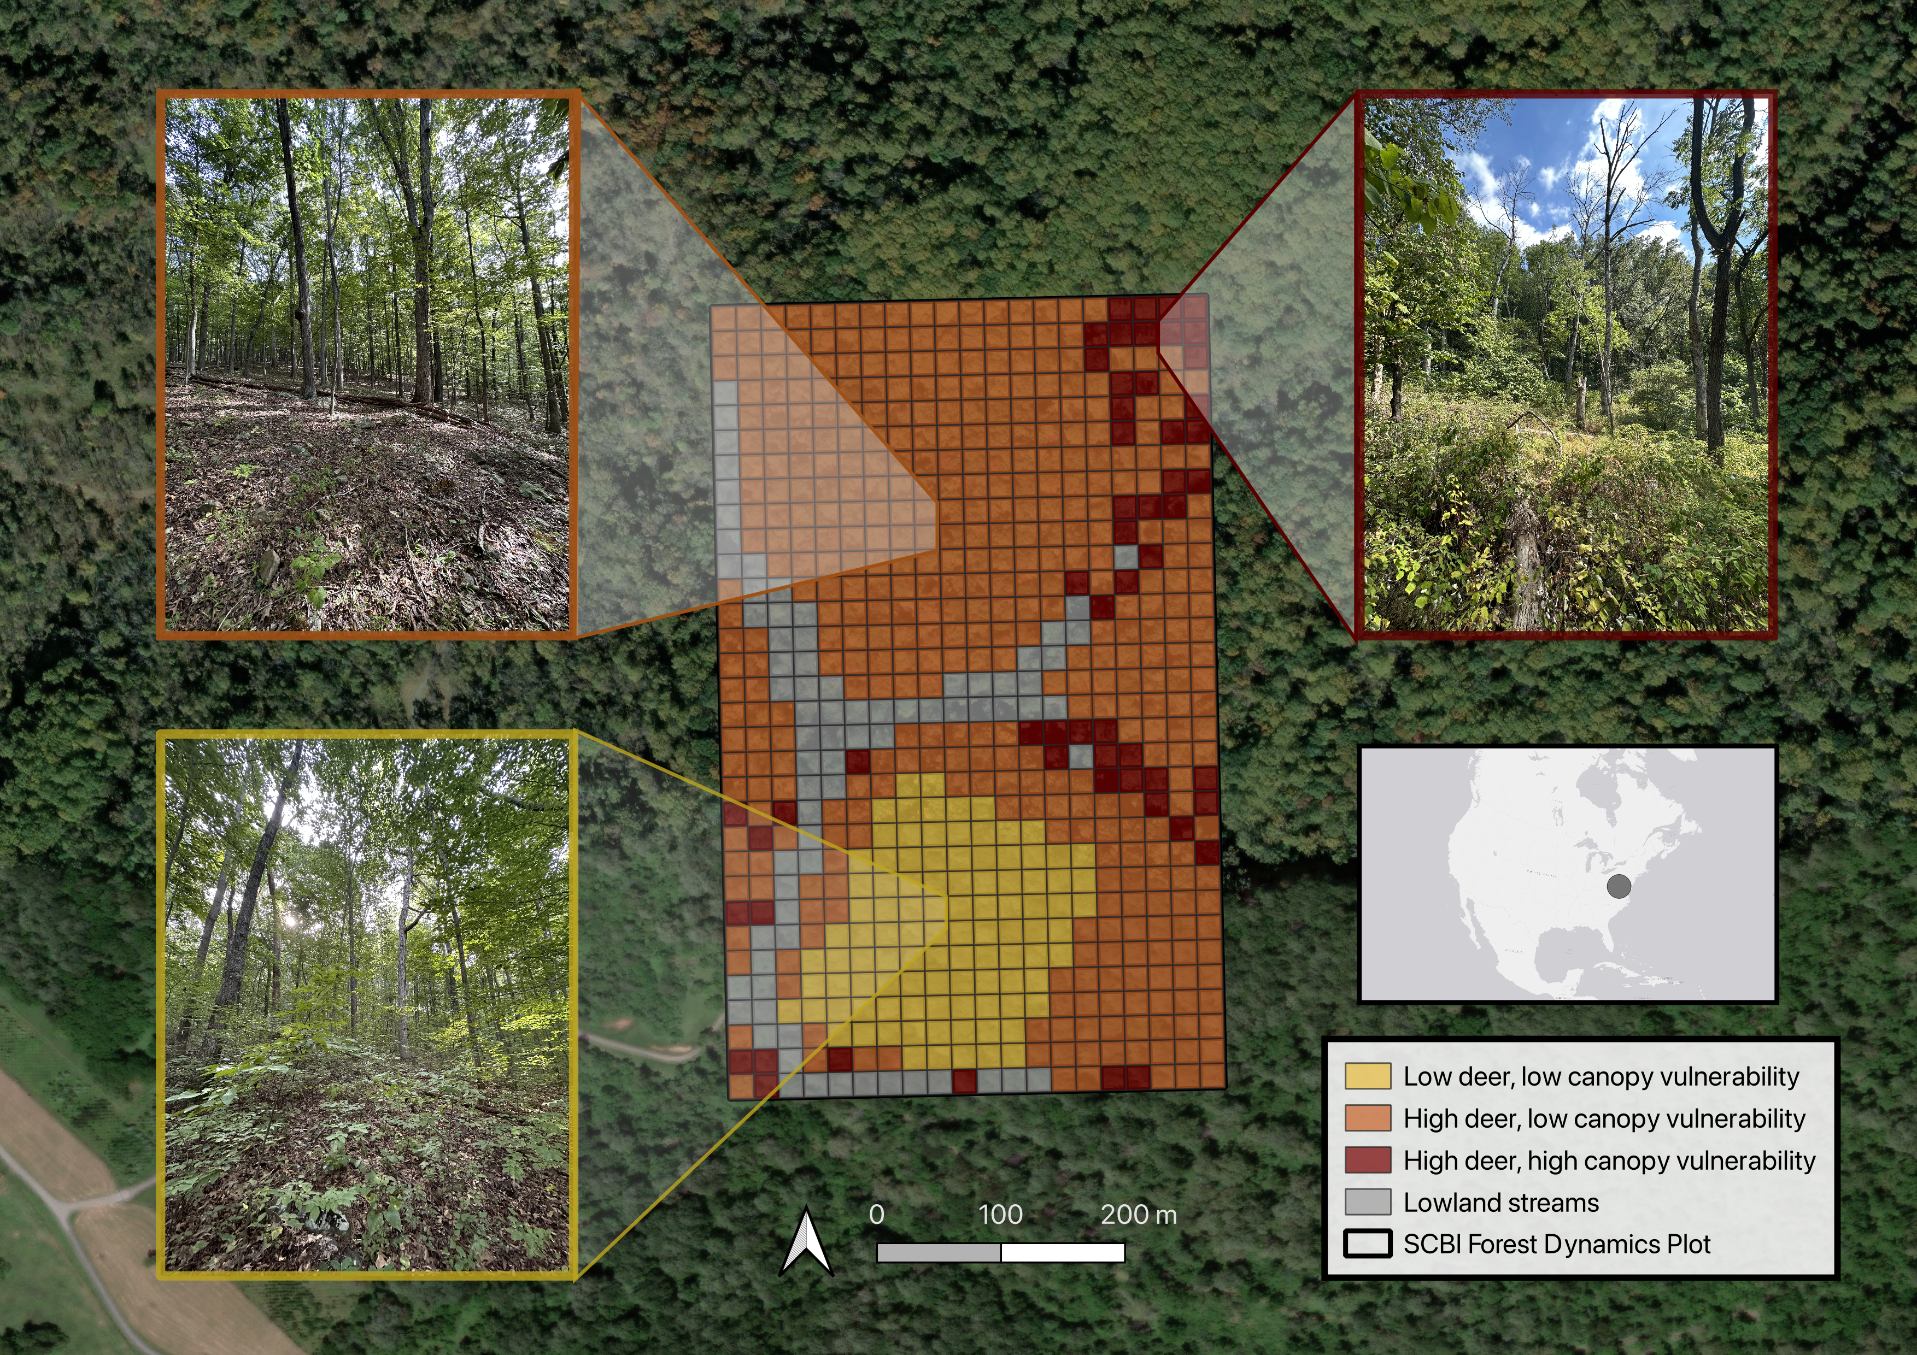

***Figure 1. Map and photos of the Forest Global Earth Observatory (ForestGEO) plot at the Smithsonian Conservation Biology Institute (SCBI) in Virginia, USA.*** Our analysis focuses on three habitat types: (a) low deer density, low abundance of canopy trees vulnerable to non-indigenous insects & pathogens, (b) high deer density, low abundance of canopy trees vulnerable to non-indigenous insects & pathogens, and (c) high deer density, high abundance of canopy trees vulnerable to non-indigenous insects & pathogens. *All photos taken September 2023 by K. Anderson-Teixeira; aerial photography from ESRI World Imagery*.

## 2.2 Data collection

As part of the ForestGEO network, the plot undergoes a comprehensive woody plant inventory every five years according to the protocol detailed in Condit (1998). This inventory, hereafter referred to as the census, includes all stems greater than one centimeter in diameter at breast height (1.3 meters; dbh). The census records information regarding the dbh, species, living status and location of each stem included in the survey. Each individual is marked with an identifying number for sequential data collection in subsequent censuses. In multi-stemmed individuals, each additional stem that surpasses the dbh threshold receives a stem number and associated tag. The plot was established in 2008 and recensused three times since, comprising 15 years of forest dynamics data. In the last census, data cleaning was continuously implemented 1) in an ESRI ArcGIS Field Maps application via built-in checks and 2) on a daily basis, via error reports generated by GitHub actions (Kim et al., 2022). Each individual’s location was recorded in the Field Maps application using a digitized map of the plot (*citation*). Additional checks and fixes were performed at the conclusion of the last census. In addition to the ForestGEO census, since 2014, a tree mortality survey has been conducted annually at the site. Initiated, in part, as a response to the presence of emerald ash borer (*Agrilus planipennis*), the mortality survey is conducted on all trees that had a dbh $≥$ 10 centimeters in the previous census. Through assessing individual tree health, we document trends in forest mortality and identify factors that are associated with death. Data is collected on the current status, canopy position, percentage of crown living and intact, and visible indicators of poor tree health, such as physical damage, potential pathogens and insect infestation.

## 2.3 Calculating biomass dynamics and stem recruitment

We estimated total aboveground biomass (AGB) from the measured dbh of each stem in each census using extra-tropical allometric equations from the R package *allodb* (Gonzalez-Akre, 2024). *allodb* creates species-specific allometric equations through weighting of all applicable allometries within its database filtered by tree size, geography, and taxa information. Using the calculated stem AGB, we estimated AGB stocks at each census year for each of the plot regions and the plot as a whole. We evaluated trends in AGB over time by calculating annualized AGB fluxes including: 1) the net change in AGB, 2) aboveground woody growth (AWG; the addition of woody biomass from tree growth), 3) aboveground woody mortality (AWM; the change of living biomass to necromass due to tree mortality), and 4) aboveground woody recruitment (AWR; the addition of living biomass through recruitment) for each census interval and plot region. We further assessed the role of nuisance species on mortality by calculating AWM flux for each year and each species using the annual mortality survey data.

In addition to the estimation of AWR biomass flux, we analyzed the effects of nuisance species on recruitment through counts of newly recruited stems. We categorized each species as either canopy or understory based on expert knowledge of life history traits. *Quercus* spp. and *Carya* spp. were grouped by genera to better assess differences between the recruitment of canopy and understory species. We then calculated the number of new stems for each census interval for each species or genera. Finally, we assessed the spatial overlap of biomass loss and recruitment of canopy species. For each .4 hectare quadrat, we calculated the net change in AGB from 2008 to 2023 and AGB stock of canopy species in the understory in 2023.

# 3 Results

For the first time since the establishment of the SCBI ForestGEO site, whole-plot aboveground C stocks decreased (Figure 2). From 2018 to 2023, whole-plot C stocks have decreased from 137.0718265 to 140.8547702 Mg C ha^-1. Both low-nuisance regions show similar decreases in C stocks going from **“X to X”** and **“X to X”** Mg C/ha, respectively. In the high deer high nuisance regions C stocks have decreased for the past two censuses, with a higher magnitude decrease of **“X to X”** Mg C/ha from 2018 to 2023. C stock decrease **is related to/ is explained by** above ground net biomass change. In the first two census intervals, 2008 to 2013 and 2013 to 2018, there were positive C fluxes, but for the 2018 to 2023 interval there was a negative C flux of **VALUE** Mg C/ha/year (Figure 3a).

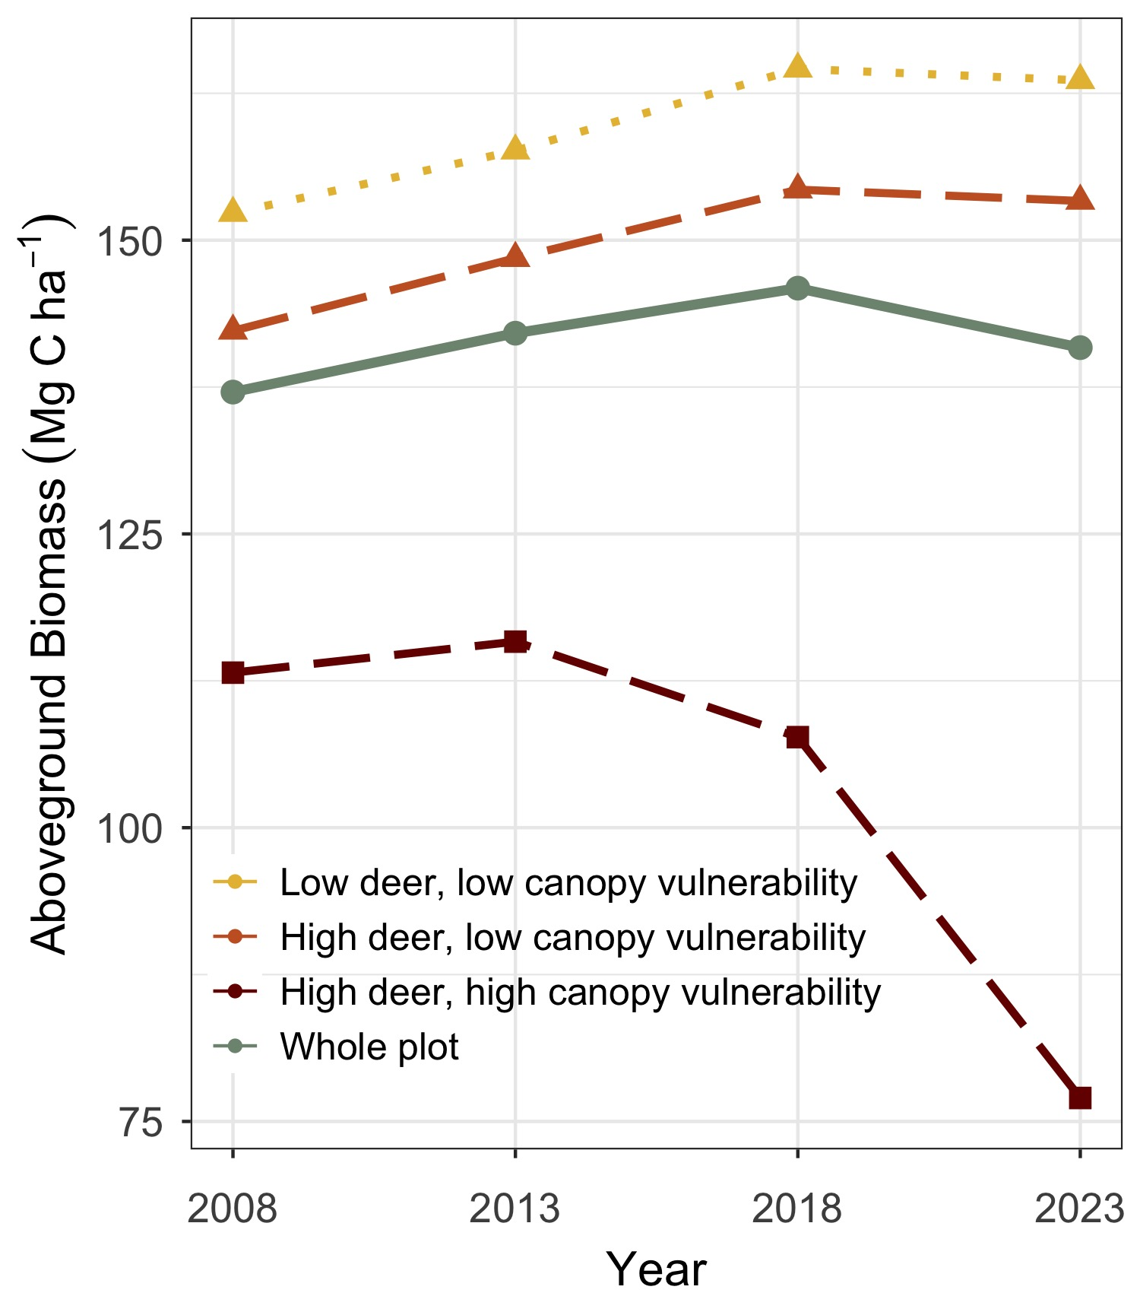

***Figure 2. Aboveground biomass at the SCBI ForestGEO plot since 2008 establishment.*** Values are shown for the plot as a whole and for habitats differentiated by intensity of deer browsing and 2008 abundance of canopy tree species vulnerable to non-indigenous pests and pathogens.

The trend in net woody production can be explained by its constituent fluxes (Figure 3). Trends in woody mortality show that for the first two census intervals, the whole plot has lost **VALUE** and then **VALUE** Mg C/ha/year, increasing to a loss of **VALUE** Mg C/ha/year for the most recent census interval (Figure 3b). Woody productivity contributes positively to the flux, showing that the whole plot gained **VALUE** Mg C/ha/year in the first interval, **VALUE** Mg C/ha/year in the second, and **VALUE** Mg C/ha/year in the third (Figure 3c). Areas of low deer, low nuisance species were consistently the most productive ending at **VALUE** Mg C/ha/year in the interval 2018 to 2023, and areas of high deer, high nuisance species were the least productive at **VALUE** Mg C/ha/year in the interval 2018 to 2023. Recruitment has consistently added smaller magnitude amounts of carbon with the whole plot gaining **VALUE** Mg C/ha/year (Figure 3d). Recruitment was highest at **VALUE** Mg C/ha/year in areas with high deer and high vulnerable species, and lowest at **VALUE** Mg C/ha/year in areas with high deer and low vulnerable species.

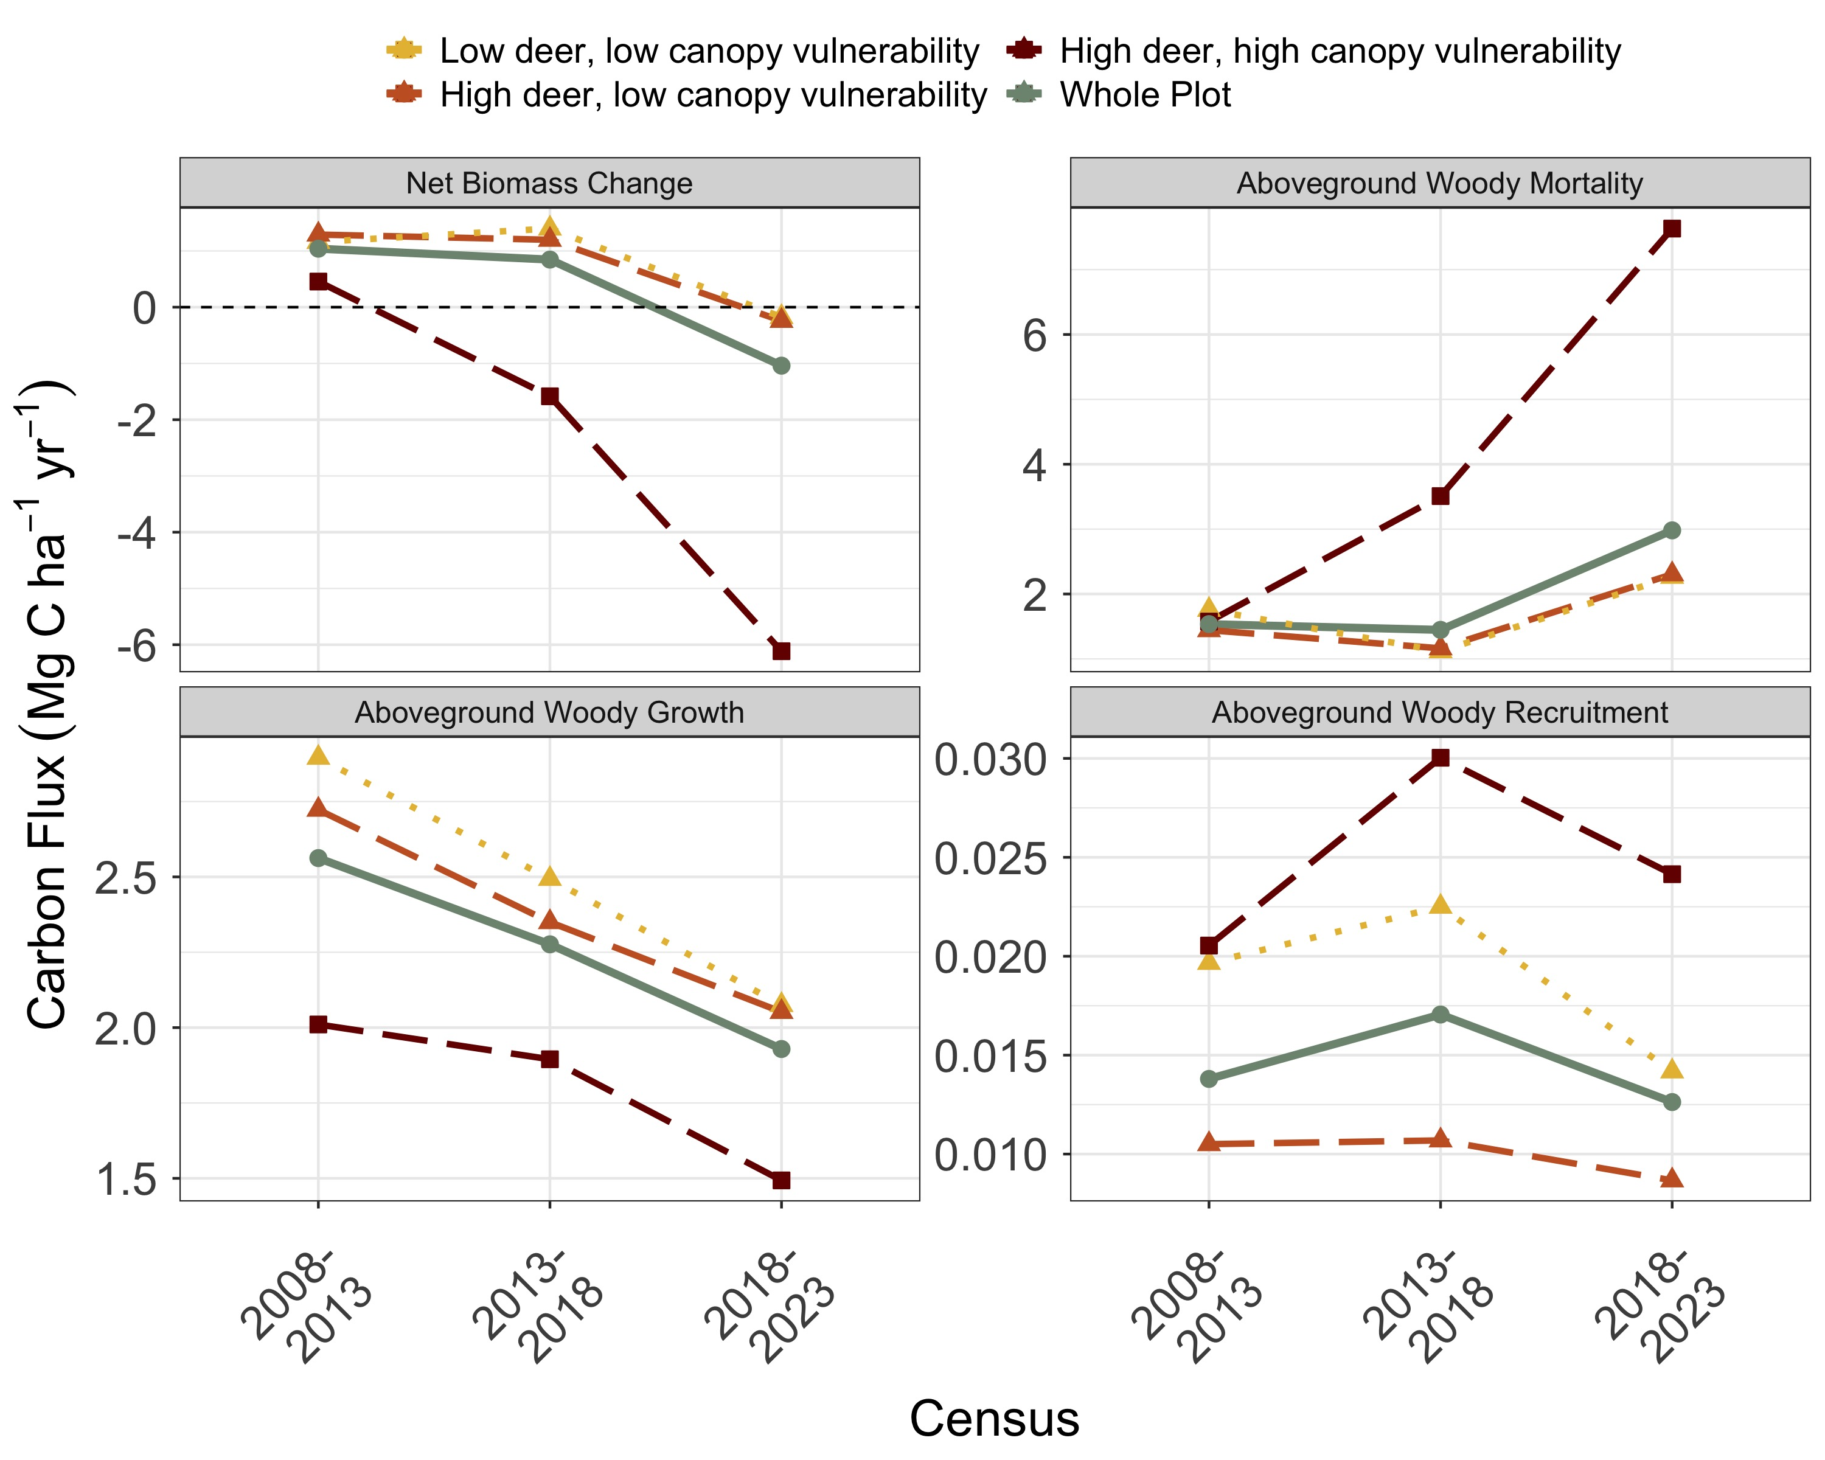

***Figure 3. Changes in aboveground woody biomass at the SCBI ForestGEO plot over each census interval since 2008 establishment, including (a) net change, (b) losses to mortality, and gains from (c) woody productivity and (d) recruitment.*** Values are shown for the plot as a whole and for habitats differentiated by intensity of deer browsing and 2008 abundance of canopy tree species vulnerable to non-indigenous pests and pathogens.

## 3.1 Species composition of mortality flux

Woody mortality was the primary driver of the negative trend in biomass, and certain species were responsible for higher levels of mortality. Fraxinus americana had the highest aboveground woody mortality rates of any species present on the plot, peaking at **VALUE** Mg C/ha/year lost in *2020* , and **VALUE** Mg C/ha/year lost in 2022 (Figure 4). Quercus velutina contributed the second-highest levels of mortality, losing **VALUE** Mg C/ha/year in 2022. Quercus rubra, Carya species, Quercus prinus, Quercus alba, and Liriodendron tulipifera were all significant contributors as well.

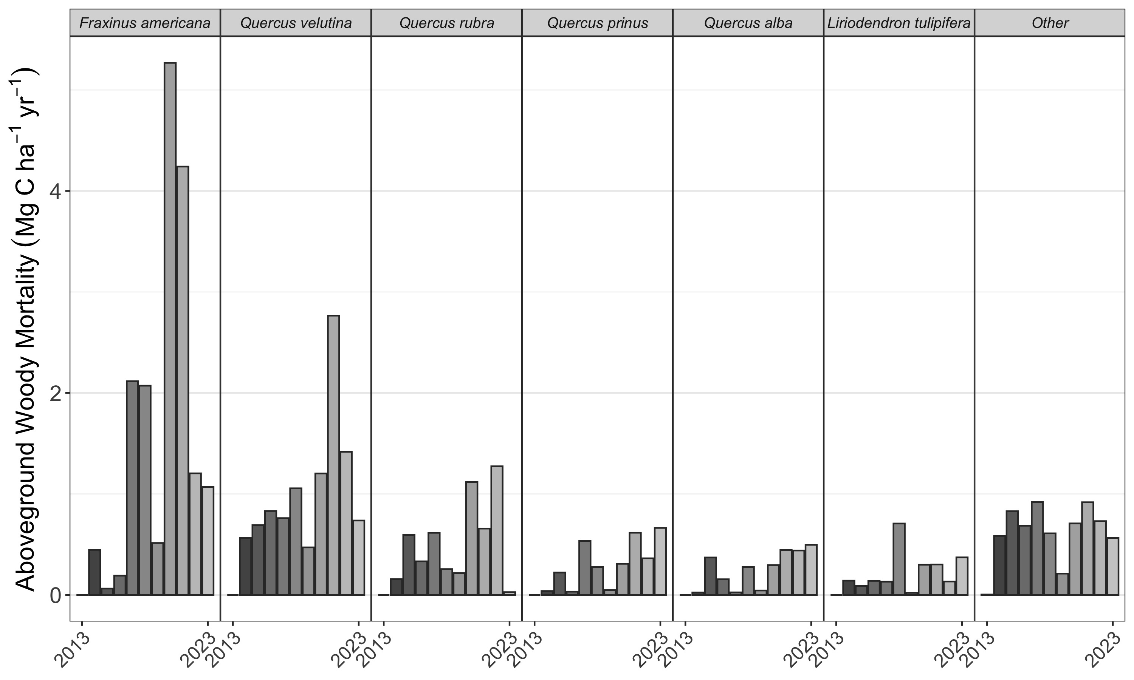

***Figure 4. Annual woody mortality by species at the SCBI ForestGEO plot from 2008-2023.*** Shown are the seven canopy taxa with highest average mortality rate in descending order and a category including all others. The census included all stems ≥ 10cm in the most recent full census.

## 3.2 Species composition of recruitment flux

Certain species dominated aboveground woody recruitment, with understory species being recruited at higher rates than canopy species (Figure 5). Out of the canopy species, Carya species showed the highest levels of recruitment with a rate of **VALUE** Mg C/ha/year recruited from 2018 to 2023 (Figure 5a). Acer negundo had the second highest rate of recruitment for canopy species at **VALUE** Mg C/ha/year from 2018 to 2023. Fagus grandifolia, Fraxinus americana, and Ulmus rubra are the other species with the highest recruitment rates. Most canopy species had lower recruitment rates in the 2018 to 2023 census interval than the 2008 to 2013 interval. Lindera benzoin had by far the highest recruitment rate of the understory species at **VALUE** Mg C/ha/year from 2018 to 2023 (Figure 3b). Asimina triloba had the second highest rate of recruitment of the understory species at **VALUE** Mg C/ha/year recruited from 2018 to 2023. Other understory species with high recruitment were Carpinus caroliniana, Hamamelis virginiana, and Celtis occidentalis.

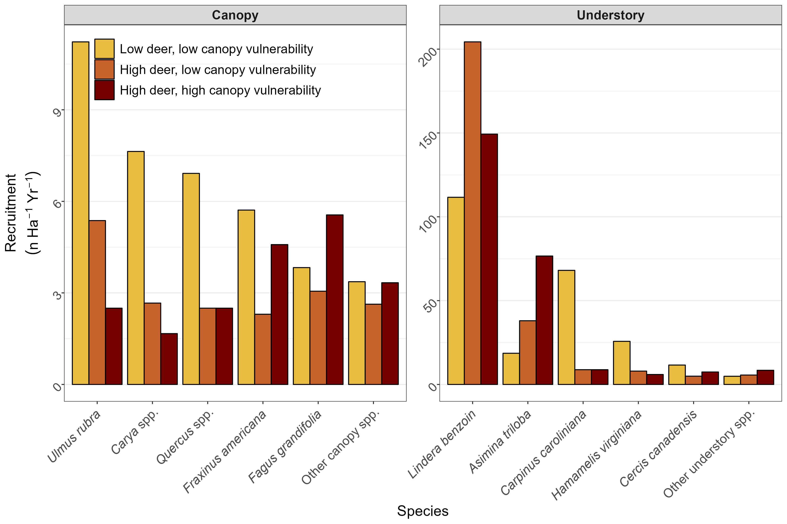

***Figure 5. Average annual recruitment (2008-2023) of canopy and understory tree species at the SCBI ForestGEO plot across habitats differentiated by intensity of deer browsing and 2008 abundance of canopy tree species vulnerable to non-indigenous pests and pathogens.*** Note that y-axes differ, with understory species recruitment >20x that of canopy species recruitment.

## 3.3 Regeneration & mortality mismatch

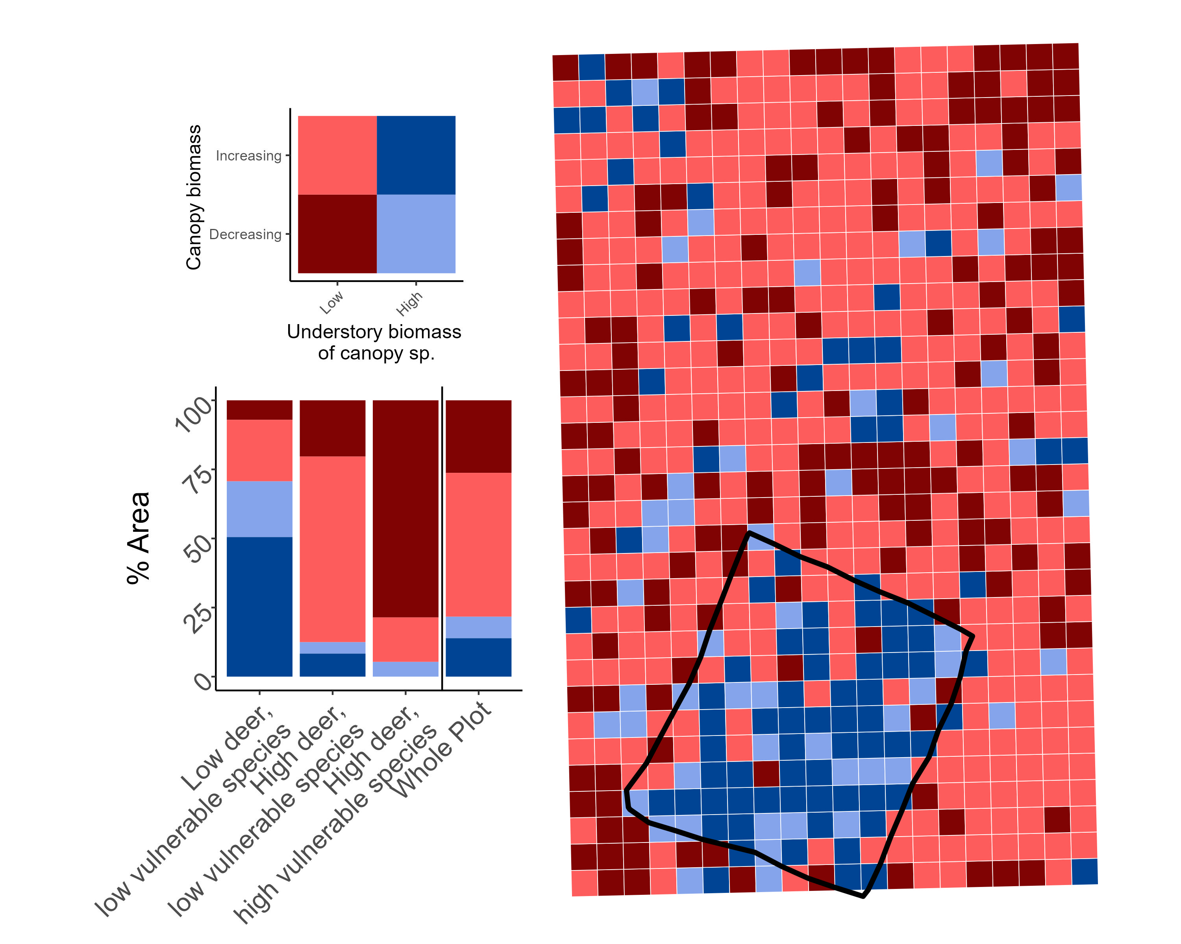

***Figure 6.***

# 4 Discussion

We found that the combination of decreasing biomass (driven by increasing woody mortality) and limited recruitment of canopy species in the understory is compromising the potential the carbon sink, now and into the future. Differences in AGB were the biggest in the regions of the plot with high vulnerability to nuisance species. These regions also had the lowest amount of canopy species in the understory. Areas with low deer population had the highest amount of canopy species in the understory. Some of the plot is increasing biomass, notably those with low proportions of vulnerable species. On net, these increases are not outpacing mortality. Suggests that the combination of heavy deer browsing on canopy species may be exacerbated in areas with canopy openings due to pathogen-derived mortality where understory species that are resistant to deer and fast growers can take advantage, further competing with canopy species. While Emerald Ash-borer has had a large impact on biomass loss at our site, mortality among oak species, which is not linked to a non-indigenous pest, is substantial as well. Oak species in the region are generally found in older, even aged cohorts, which contributes to accelerated mortality rates (Oak et al., 2016). However, large oak mortality events, which often occur over protracted periods of time, have been common globally over the past century. These mortality events are often termed “oak decline” events due to the complex abiotic and biotic factors which interact to incite mortality (Manion and Lachance, 1992). Oak decline is believed to be the result of an imbalance in carbohydrate dynamics, which weakens oak trees’ resistance to pest and pathogen invasion, eventually leading to mortality (Manion and Lachance, 1992).

Using current understory as a predictor of the future canopy is imperfect. Some canopy species (examples) recruit in pulse events - if there is a shift in deer population and enough survival that coincides with a mast year than you could get regeneration into the canopy. However, current recruitment levels are below a rate at which we would expect in maturing secondary forests and may be insufficient to prevent large periods without a close canopy. Our data is from just the single site, which can make generalizability challenging. However, there is a lot of support that the drivers we identify here are representative of the region. Mixed hardwood forests are typical of mid-Atlantic forests and deer populations are high throughout the region. Vulnerable species (ash) are also common throughout these forests, and emerald ash borer continues to spread. Where it does spread it consistently decimates adult ash. Our results underscore the importance of accounting for nuisance species in higher-level models and understanding of temperate forests. Nuisance species (driven by human pressures/actions) interact with other anthropogenic changes to modify forest ecosystems. Have the capacity to alter short-term dynamics: large carbon losses that would not be expected in models that don’t exclude it. Longer-term have capacity to alter successional dynamics: can delay recovery from disturbances (including other disturbances) or even suppress regeneration into a closed-canopy for sustained periods. Decrease resilience to other pressures as pests and pathogens decrease diversity through shrinking the number of possible canopy species. Positive takeaways: this work highlights the potential of active management. Preserving the forests that we have is more valuable than planting new forests. Pests and pathogens are driving mortality - may be opportunities for treatment/prevention of spread. Research into natural immunity (ash species in original range of EAB have immunity). Management of deer populations to decrease browsing pressure - deer exclosure shows the importance to maintain an understory.

# 5 Conclusions /Future Directions

Expand analyses across other temperate forests. Different forest compositions and herbivory dynamics, but many pests and pathogens. Leverage other forest dynamics sites to quantify the impact of nuisance species across large regions. Investigate productivity responses of surviving canopy. We would expect survivors adjacent to gaps increase productivity as competition decreases, but may be hampered by climate change. Interactions of global change drivers are critical to understand (though difficult to study).

# Acknowledgements

* Funding: ForestGEO

# Competing Interests

The authors declare no conflict of interest.

# Author Contributions

*[Name of author 1] and [Name of author 2] conceived the ideas and designed methodology; [Name of author 1] and [Name of author 3] collected the data; [Name of author 2] and [Name of author 4] analysed the data; [Name of author 1] and [Name of author 4] led the writing of the manuscript. All authors contributed critically to the drafts and gave final approval for publication.*

# Data availability

# References

**Ahlström A, Schurgers G, Arneth A, Smith B**. **2012**. [Robustness and uncertainty in terrestrial ecosystem carbon response to CMIP5 climate change projections](https://doi.org/10.1088/1748-9326/7/4/044008). *Environmental Research Letters* **7**: 044008.

**Anderson-Teixeira KJ, Miller AD, Mohan JE, Hudiburg TW, Duval BD, DeLucia EH**. **2013**. [Altered dynamics of forest recovery under a changing climate](https://doi.org/10.1111/gcb.12194). *Global Change Biology* **19**: 2001–2021.

**Arora VK, Katavouta A, Williams RG, Jones CD, Brovkin V, Friedlingstein P, Schwinger J, Bopp L, Boucher O, Cadule P, *et al.*** **2020**. [Carbon concentration and carbon climate feedbacks in CMIP6 models and their comparison to CMIP5 models](https://doi.org/10.5194/bg-17-4173-2020). *Biogeosciences* **17**: 4173–4222.

**Clark JS, Andrus R, Aubry-Kientz M, Bergeron Y, Bogdziewicz M, Bragg DC, Brockway D, Cleavitt NL, Cohen S, Courbaud B, *et al.*** **2021**. [Continent-wide tree fecundity driven by indirect climate effects](https://doi.org/10.1038/s41467-020-20836-3). *Nature Communications* **12**: 1242.

**Fatichi S, Leuzinger S, Körner C**. **2014**. [Moving beyond photosynthesis: From carbon source to sink-driven vegetation modeling](https://www.jstor.org/stable/newphytologist.201.4.1086). *The New Phytologist* **201**: 1086–1095.

**Gorchov DL, Blossey B, Averill KM, Dávalos A, Heberling JM, Jenkins MA, Kalisz S, McShea WJ, Morrison JA, Nuzzo V, *et al.*** **2021**. [Differential and interacting impacts of invasive plants and white-tailed deer in eastern U.S. forests](https://doi.org/10.1007/s10530-021-02551-2). *Biological Invasions* **23**: 2711–2727.

**Harris NL, Gibbs DA, Baccini A, Birdsey RA, Bruin S de, Farina M, Fatoyinbo L, Hansen MC, Herold M, Houghton RA, *et al.*** **2021**. [Global maps of twenty-first century forest carbon fluxes](https://doi.org/10.1038/s41558-020-00976-6). *Nature Climate Change*: 1–7.

**McDowell NG, Allen CD, Anderson-Teixeira K, Aukema BH, Bond-Lamberty B, Chini L, Clark JS, Dietze M, Grossiord C, Hanbury-Brown A, *et al.*** **2020**. [Pervasive shifts in forest dynamics in a changing world](https://doi.org/10.1126/science.aaz9463). *Science* **368**.

**McGregor IR, Helcoski R, Kunert N, Tepley AJ, Gonzalez-Akre EB, Herrmann V, Zailaa J, Stovall AEL, Bourg NA, McShea WJ, *et al.*** **2021**. [Tree height and leaf drought tolerance traits shape growth responses across droughts in a temperate broadleaf forest](https://doi.org/10.1111/nph.16996). *New Phytologist* **231**: 601–616.

**Miller KM, McGill BJ**. **2019**. [Compounding human stressors cause major regeneration debt in over half of eastern US forests](https://doi.org/10.1111/1365-2664.13375). *Journal of Applied Ecology* **56**: 1355–1366.

**Miller KM, Perles SJ, Schmit JP, Matthews ER, Weed AS, Comiskey JA, Marshall MR, Nelson P, Fisichelli NA**. **2023**. [Overabundant deer and invasive plants drive widespread regeneration debt in eastern United States national parks](https://doi.org/10.1002/eap.2837). *Ecological Applications* **33**: e2837.

**Nowacki GJ, Abrams MD**. **2015**. [Is climate an important driver of post-European vegetation change in the Eastern United States?](https://doi.org/10.1111/gcb.12663) *Global Change Biology* **21**: 314–334.

**Pugh TAM, Lindeskog M, Smith B, Poulter B, Arneth A, Haverd V, Calle L**. **2019**. [Role of forest regrowth in global carbon sink dynamics](https://doi.org/10.1073/pnas.1810512116). *Proceedings of the National Academy of Sciences* **116**: 4382–4387.

**Russell MB, Woodall CW, Potter KM, Walters BF, Domke GM, Oswalt CM**. **2017**. [Interactions between white-tailed deer density and the composition of forest understories in the northern United States](https://doi.org/10.1016/j.foreco.2016.10.038). *Forest Ecology and Management* **384**: 26–33.

**Wu C, Coffield SR, Goulden ML, Randerson JT, Trugman AT, Anderegg WRL**. **2023**. [Uncertainty in US forest carbon storage potential due to climate risks](https://doi.org/10.1038/s41561-023-01166-7). *Nature Geoscience*: 1–8.

# 6 Supporting Information